Team 1
DATS 6103
Professor Ning Rui
December 11, 2025
Mental Health Patterns and Living Situations in New York State
Mental health and housing stability are ongoing crises in New York state. Many New York residents have a mental illness which can be triggered by financial stress, limited health insurance coverage, and overall less support. The Substance Abuse and Mental Health Services Administration reported that roughly 19.5 percent of adults who live in New York had a mental illness, with about 3.7 percent having a serious mental illness in 2019 (SAMHSA, 2019).
New York, like many states in the nation, is facing a housing crisis. With high housing costs and a limited supply, it is growing increasingly difficult for New York State residents to have housing stability. Urban areas, New York City especially, have some of the highest housing costs in the country, while New York’s more rural and suburban areas face lack of housing supply (New York State Housing and Community Renewal, 2019). A struggling housing market can catalyze/worsen stress, financial strain, making individuals more vulnerable to mental illness. Economic insecurity and stress are linked to higher rates of depression among other mental illnesses (Tanarsuwongkul et al., 2025).
Data Description
In this project, we utilize the 2019 Patient Characteristic Survey (PCS) for New York state to analyze relationships between demographic, socioeconomic, housing, and mental health variables. The PCS dataset provides comprehensive information on these issues since it includes information on a variety of mental health, housing stability, demographic, and socioeconomic variables. It is important to note that the PCS reports that over 90 percent of patients claimed to have some kind of a mental illness. The high prevalence of those who have a mental health illness reflects that the sampled group is part of a clinical population that is already receiving healthcare services.
Although the PCS consists of all types of patients, some survey participants are already receiving mental health treatment. Furthermore, mental illness commonly results with physical health conditions such as diabetes, obesity, chronic pain, among others (Moussavi et al., 2007; Katon, 2011). When patients seek physical health treatments, mental illnesses are sometimes also tested for with screenings. Focusing on a clinical population offers invaluable insights into how demographic, socioeconomic, mental health, and housing conditions interact, informing policies to improve mental health outcomes for patients in New York.
Because over 90 percent of individuals included in the PCS reported having a mental health diagnosis, our dataset has a class imbalance, which we will address in our statistical modeling.
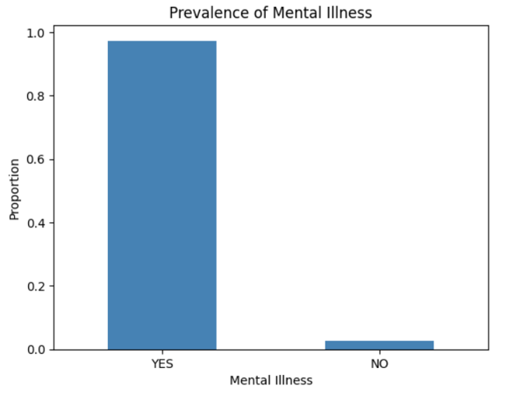

SMART Questions
We focused on the relationships between the prevalence of mental illness and demographic, socioeconomic, and housing stability variables. The questions we examined are as follows:
- How well can demographic characteristics predict whether an adult has a diagnosed mental illness in New York State using PCS 2019 data?
- To what extent can socio-economic factors, particularly educational attainment, predict mental health diagnosis among adults in New York State using PCS 2019, and which variables are the strongest predictors?
- How effectively can employment and related socioeconomic variables predict an individual’s living situation category in New York State using PCS 2019?
Data Cleaning
We first subsetted and filtered our data using column names based on each SMART question. For example, the first question was filtered to only use necessary columns that included mental health illness and demographic variables. Since PCS data is “YES/NO/UNKNOWN” data, we converted “UNKNOWN” values into missing values and then removed the missing values. We then encoded the categorical variables to be able to run statistical models. After data cleaning, we had 146,737 observations.
SMART Question 1

